DATA HANDLING AND VISUALIZATION ACTIVITIES
Question 1 – Bar Chart
Scenario: A supermarket chain wants to compare the monthly sales revenue generated by different product categories during June 2026. The management wants to identify the best and worst performing categories using an appropriate visualization.
Product Category | Sales (₹ Lakhs)
Groceries | 120
Dairy | 95
Fruits | 80
Vegetables | 75
Bakery | 68
Beverages | 90
Snacks | 110
Personal Care | 55
Household Items | 70
Frozen Foods | 60
Question: Create a Bar Chart to visualize the sales of each product category. Identify the highest and lowest selling categories and provide two observations based on the chart.
Required Visualization
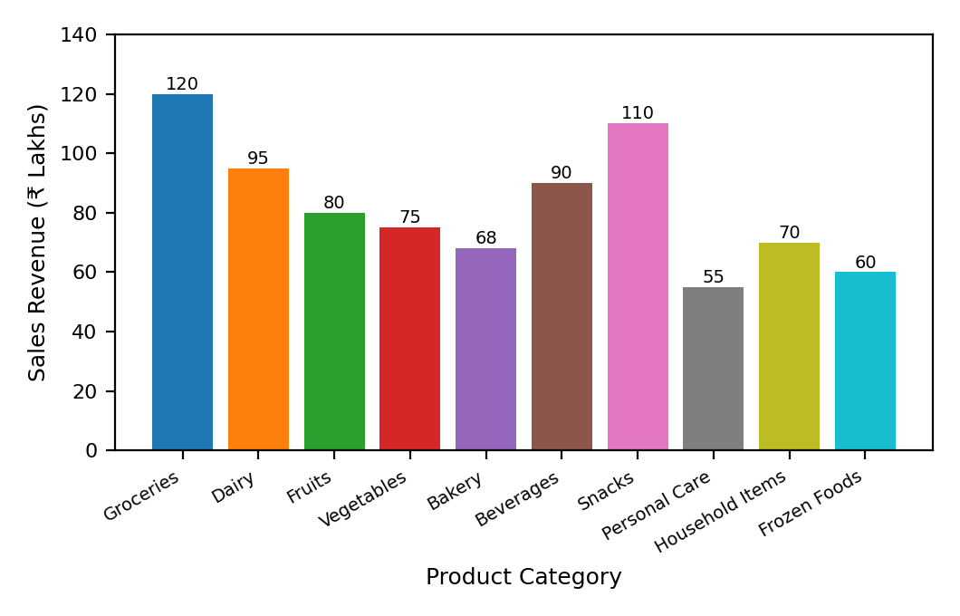
Short Analysis and Answer
Groceries is the highest selling category with sales revenue of ₹120 lakhs.
Personal Care is the lowest selling category with sales revenue of ₹55 lakhs.
Observation 1: Groceries and Snacks are the only categories with sales revenue above ₹100 lakhs.
Observation 2: The difference between the highest and lowest category sales is ₹65 lakhs, indicating considerable variation in sales performance across product categories.
Question 2 – Histogram
Scenario: A university placement cell collected the annual salary packages in LPA offered to students during the campus recruitment drive. The placement officer wants to study the distribution of salary packages.
Student | Salary Package (LPA)
S1 | 3.2
S2 | 4.5
S3 | 5.0
S4 | 6.8
S5 | 7.2
S6 | 8.5
S7 | 4.8
S8 | 5.5
S9 | 6.0
S10 | 7.8
S11 | 9.2
S12 | 10.5
Question: Construct a Histogram using the above data. Analyze the distribution of salary packages and comment on the spread, frequency, and possible outliers.
Required Visualization
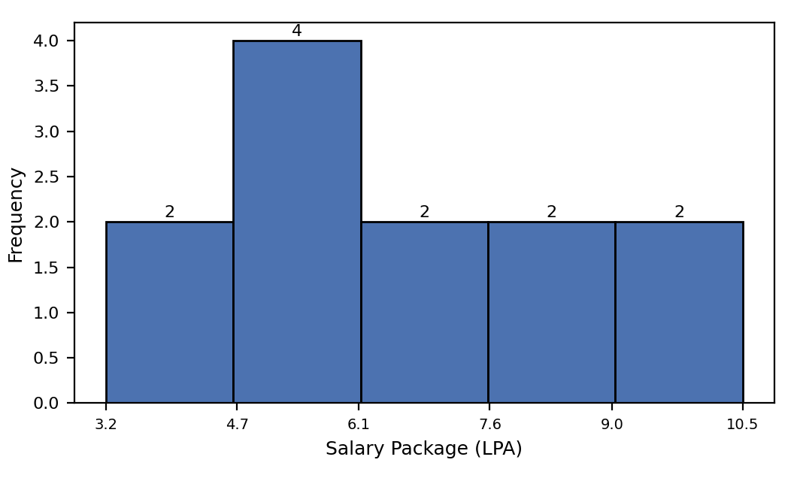
Calculations
Minimum = 3.2 LPA, Maximum = 10.5 LPA, Range = 7.3 LPA.
Mean = 79.0 / 12 ≈ 6.58 LPA. Median (average of 6th and 7th sorted values) = (6.0 + 6.8) / 2 = 6.4 LPA.
Outlier check (IQR method, splitting the sorted data into lower and upper halves): Q1 = median of lowest 6 values = (4.8 + 5.0) / 2 = 4.9 LPA. Q3 = median of highest 6 values = (7.8 + 8.5) / 2 = 8.15 LPA. IQR = Q3 − Q1 = 3.25 LPA. Lower fence = Q1 − 1.5×IQR = 0.025 LPA. Upper fence = Q3 + 1.5×IQR = 13.025 LPA. All 12 values lie within these fences.
Short Analysis and Answer
Spread: The salary packages range from 3.2 LPA to 10.5 LPA, giving a spread of 7.3 LPA.
Frequency: Most salary packages are concentrated in the middle range, approximately between 4.5 LPA and 8.5 LPA.
Distribution: The salary distribution is fairly spread out, with slightly more observations in the middle salary ranges.
Possible outliers: Based on the IQR method, there are no clear outliers in the dataset.
Question 3 – Pie Chart
Scenario: A software company allocated its annual digital marketing budget across different advertising channels. The marketing manager wants to visualize how the budget is distributed.
Marketing Channel | Budget (%)
Social Media | 28
Television | 22
Print Media | 10
Radio | 8
Email Marketing | 12
Influencer Marketing | 9
SEO | 6
Events | 5
Verification: 28 + 22 + 10 + 8 + 12 + 9 + 6 + 5 = 100% (valid pie chart).
Question: Create a Pie Chart representing the marketing budget allocation. Identify the channel with the highest investment and explain the overall distribution.
Required Visualization
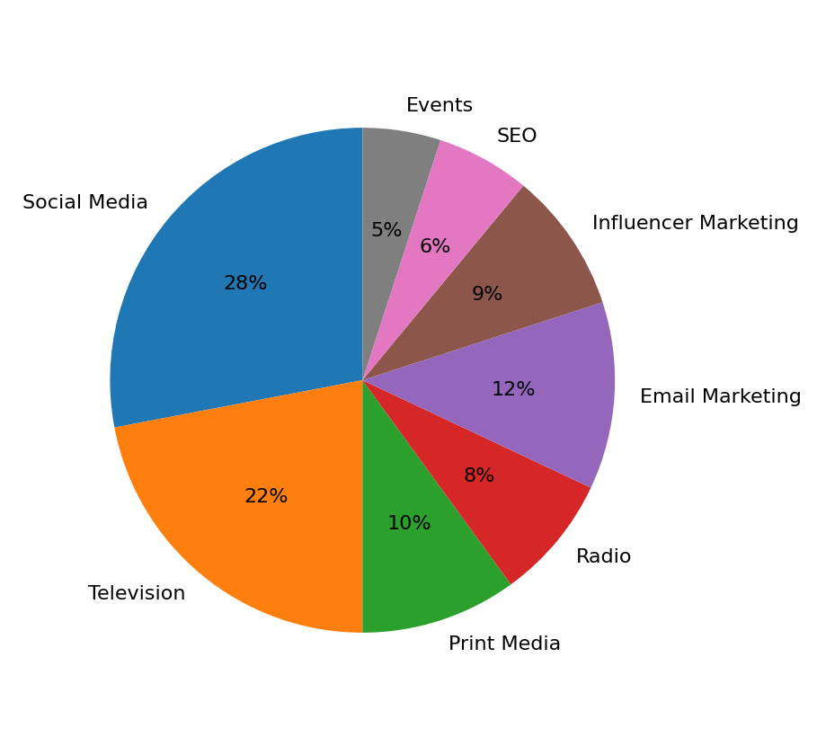
Short Analysis and Answer
Social Media receives the highest investment at 28% of the total marketing budget.
Social Media and Television together account for 50% of the total marketing budget, while the remaining 50% is distributed among six other channels.
Events receives the smallest allocation at 5%.
Question 4 – Scatter Plot
Scenario: An e-commerce company wants to determine whether advertising expenditure influences monthly sales revenue.
Month | Advertising Cost (₹ Lakhs) | Sales Revenue (₹ Lakhs)
Jan | 5 | 42
Feb | 8 | 55
Mar | 10 | 63
Apr | 12 | 70
May | 15 | 82
Jun | 18 | 91
Jul | 20 | 98
Aug | 22 | 110
Sep | 25 | 120
Oct | 28 | 132
Question: Using the above dataset, create a Scatter Plot to examine the relationship between advertising expenditure and sales revenue. Determine whether the relationship is positive, negative, or weak, and justify your answer.
Required Visualization
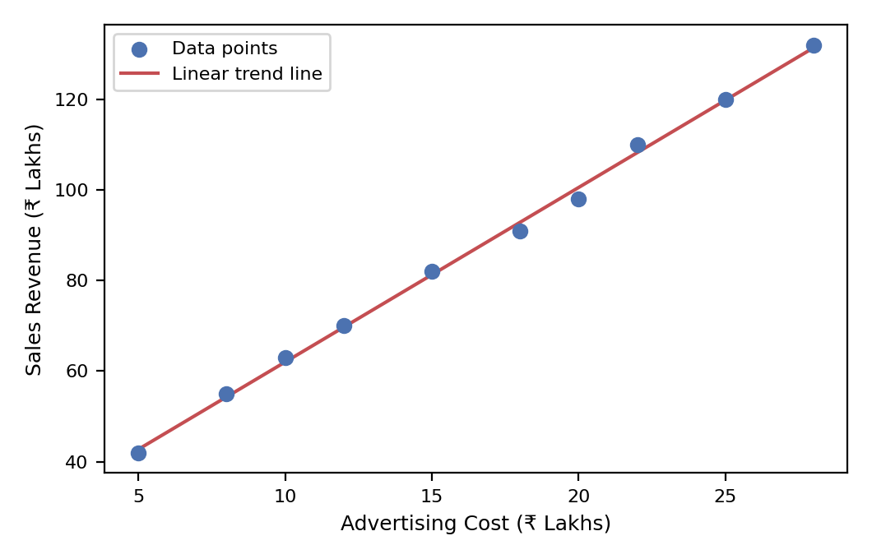
Short Analysis and Answer
The scatter plot shows a very strong positive relationship between advertising expenditure and sales revenue.
As advertising expenditure increases from ₹5 lakhs to ₹28 lakhs, sales revenue also increases from ₹42 lakhs to ₹132 lakhs.
The Pearson correlation coefficient, calculated from the exact dataset, is approximately +0.999, indicating a very strong positive linear relationship. This is a relationship/association only; it does not establish that advertising expenditure causes the increase in sales revenue.
Question 5 – Line Chart
Scenario: A renewable energy company recorded the monthly electricity generated by its solar power plant throughout the year 2025. The company wants to study the trend in electricity generation.
Month | Energy Generated (MWh)
January | 420
February | 450
March | 490
April | 530
May | 560
June | 600
July | 580
August | 590
September | 610
October | 630
November | 590
December | 540
Question: Construct a Line Chart using the above data. Analyze the monthly trend in electricity generation and identify the months with the highest and lowest energy production. Also comment on any seasonal variations observed in the data.
Required Visualization
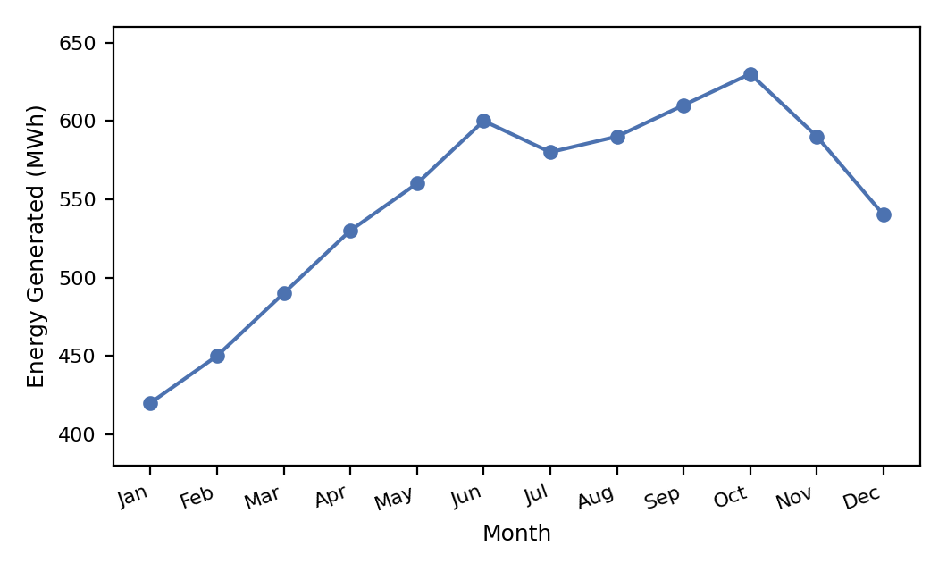
Short Analysis and Answer
October has the highest electricity generation at 630 MWh.
January has the lowest electricity generation at 420 MWh.
Trend: Electricity generation increases steadily from January to June, decreases slightly in July, rises again to reach the yearly peak in October, and then declines during November and December.
Seasonal variation: The data shows lower electricity generation at the beginning and end of the year and generally higher generation during the middle and later months of the year.

